DOLARF

Switching( 3) Modelling DLClose_filled by MS(3)
The dataset is: C:\Users\bteba\Documents\GitHub\MarkovSwitchingModel\database\filled\DOLARF_filled.csv
The estimation sample is: 2005-11-22 - 2025-11-20

Coefficient Std.Error t-value t-prob
Constant(0) -0.000270574 0.0001238 -2.19 0.029
Constant(1) 0.000295245 0.0002125 1.39 0.165
Constant(2) 0.00237155 0.001472 1.61 0.107
DLClose_filled_1(0) 0.107928 0.02728 3.96 0.000
DLClose_filled_1(1) 0.0973230 0.02100 4.64 0.000
DLClose_filled_1(2) -0.0868139 0.06308 -1.38 0.169

Coefficient Std.Error
sigma(0) 0.00460227 0.0002462
sigma(1) 0.00892679 0.0005341
sigma(2) 0.0229348 0.001764
p_{0|0} 0.964392 0.007111
p_{1|0} 0.0348232 0.007758
p_{0|1} 0.0276969 0.009014
p_{1|1} 0.960764 0.008310
p_{1|2} 0.104380 0.03006
p_{2|2} 0.890216 0.02765

log-likelihood 18012.0154
no. of observations 5218 no. of parameters 15
AIC -6.89805114 SC -6.87919372
mean(DLClose_filled) 0.00016818 se(DLClose_filled) 0.00909683

Linearity LR-test Chi^2(12) = 1775.7 [0.0000]** approximate upperbound: [0.0000]**

Transition probabilities p_{i|j} = P(Regime i at t+1 | Regime j at t)
Regime 0,t Regime 1,t Regime 2,t
Regime 0,t+1 0.96439 0.027697 0.0054032
Regime 1,t+1 0.034823 0.96076 0.10438
Regime 2,t+1 0.00078475 0.011539 0.89022

Used uniform probabilities to start recursion
Std.Error based on numerical Hessian matrix
SQPF using analytical derivatives (eps1=0.0001; eps2=0.005):
Strong convergence
Used starting values:
0.00020264 -0.0014900 0.0038013 0.080831 0.062695 -0.047383 0.0053386 0.0087741 0.018336 0.94222 0.037810 0.10189 0.82818 0.18551 0.76093

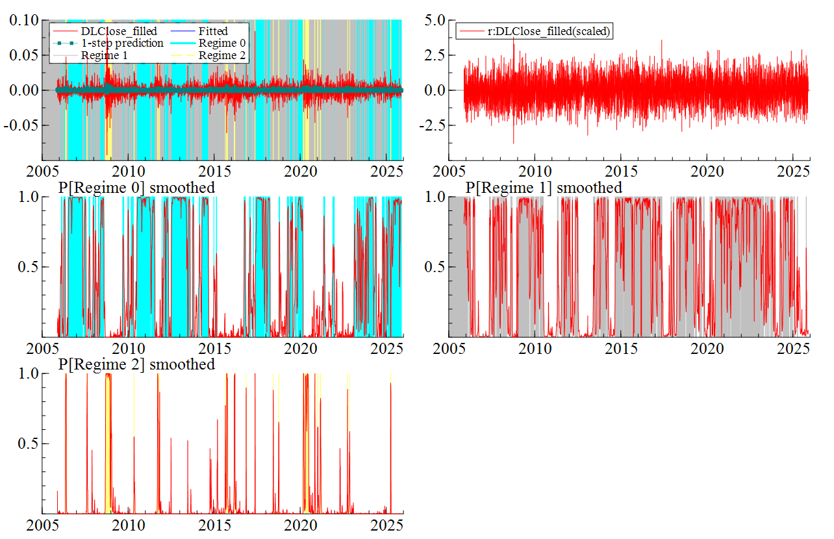

IBOV

Switching( 4) Modelling DLClose_filled by MS(3)
The dataset is: C:\Users\bteba\Documents\GitHub\MarkovSwitchingModel\database\filled\IBOV_filled.csv
The estimation sample is: 2005-11-22 - 2025-11-20
Warning in invertgen: invertsym failed, proceeding with generalized p.s.d. inverse: decomposition failed
D:/OxMetrics9/apps_dev/packages/switchpack/switchcore.ox (3232): CovarMSAR

Coefficient Std.Error t-value t-prob
Constant(0) 0.000869419 0.0001966 4.42 0.000
Constant(1) -0.000167840 0.0004432 -0.379 0.705
Constant(2) -0.00947842 0.005433 -1.74 0.081
DLClose_filled_1(0) 0.00494611 0.02158 0.229 0.819
DLClose_filled_1(1) -0.0300719 0.02468 -1.22 0.223
DLClose_filled_1(2) -0.174747 0.09494 -1.84 0.066

Coefficient Std.Error
sigma(0) 0.0100480 0.0002910
sigma(1) 0.0178533 0.0004762
sigma(2) 0.0560414 0.004134
p_{0|0} 0.984804 0.004886
p_{1|0} 0.0144456 0.004954
p_{0|1} 0.0261474 0.006814
p_{1|1} 0.971342 0.007011
p_{1|2} 0.0621317 0.02627
p_{2|2} 0.937867 0.02635

log-likelihood 15119.372
no. of observations 5218 no. of parameters 15
AIC -5.78933385 SC -5.77047642
mean(DLClose_filled) 0.000307476 se(DLClose_filled) 0.0158203

Linearity LR-test Chi^2(12) = 1759.2 [0.0000]** approximate upperbound: [0.0000]**

Transition probabilities p_{i|j} = P(Regime i at t+1 | Regime j at t)
Regime 0,t Regime 1,t Regime 2,t
Regime 0,t+1 0.98480 0.026147 1.4499e-06
Regime 1,t+1 0.014446 0.97134 0.062132
Regime 2,t+1 0.00075015 0.0025107 0.93787

Used uniform probabilities to start recursion
Std.Error based on numerical Hessian matrix
SQPF using analytical derivatives (eps1=0.0001; eps2=0.005):
Strong convergence
Used starting values:
0.0011001 -0.0018018 -0.00092594 -0.0020112 -0.030286 -0.14284 0.010199 0.017867 0.042653 0.94784 0.032450 0.085879 0.85640 0.23636 0.65540

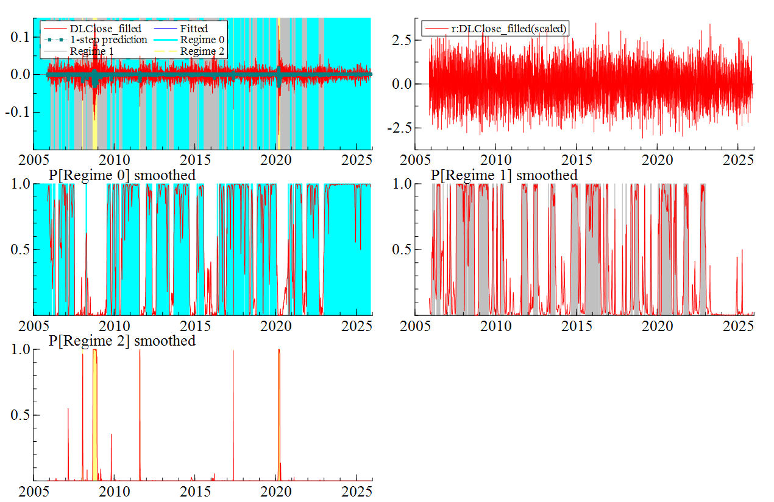

NASDAQ

Switching( 5) Modelling DLClose_filled by MS(3)
The dataset is: C:\Users\bteba\Documents\GitHub\MarkovSwitchingModel\database\filled\NASDAQ_filled.csv
The estimation sample is: 2005-11-22 - 2025-11-20

Coefficient Std.Error t-value t-prob
Constant(0) 0.00160576 0.0001552 10.3 0.000
Constant(1) -0.000474362 0.0003314 -1.43 0.152
Constant(2) -0.00398114 0.002287 -1.74 0.082
DLClose_filled_1(0) -0.0387537 0.02224 -1.74 0.082
DLClose_filled_1(1) -0.0170658 0.02236 -0.763 0.445
DLClose_filled_1(2) -0.246788 0.06244 -3.95 0.000

Coefficient Std.Error
sigma(0) 0.00674572 0.0001798
sigma(1) 0.0146124 0.0003293
sigma(2) 0.0349217 0.002047
p_{0|0} 0.971412 0.005510
p_{0|1} 0.0337882 0.006148
p_{1|1} 0.961949 0.006389
p_{2|2} 0.963692 0.01492

log-likelihood 16183.1465
no. of observations 5218 no. of parameters 13
AIC -6.19783309 SC -6.18148999
mean(DLClose_filled) 0.00043836 se(DLClose_filled) 0.0135391

Linearity LR-test Chi^2(10) = 2232.8 [0.0000]** approximate upperbound: [0.0000]**

Transition probabilities p_{i|j} = P(Regime i at t+1 | Regime j at t)
Regime 0,t Regime 1,t Regime 2,t
Regime 0,t+1 0.97141 0.033788 0.00000
Regime 1,t+1 0.028588 0.96195 0.036308
Regime 2,t+1 0.00000 0.0042628 0.96369

Transition probability settings (-1: free parameter, -2: 1-sum(p_{i|.})
Regime 0,t Regime 1,t Regime 2,t
Regime 0,t+1 -1.0000 -1.0000 0.00000
Regime 1,t+1 -2.0000 -1.0000 -2.0000
Regime 2,t+1 0.00000 -2.0000 -1.0000

Used uniform probabilities to start recursion
Std.Error based on numerical Hessian matrix
SQPF using analytical derivatives (eps1=0.0001; eps2=0.005):
Strong convergence
Used starting values:
0.0015112 -0.0020328 -0.00055511 -0.011657 -0.041815 -0.25014 0.0075638 0.016170 0.032320 0.95298 0.027338 0.056125 0.86928 0.28434 0.63810

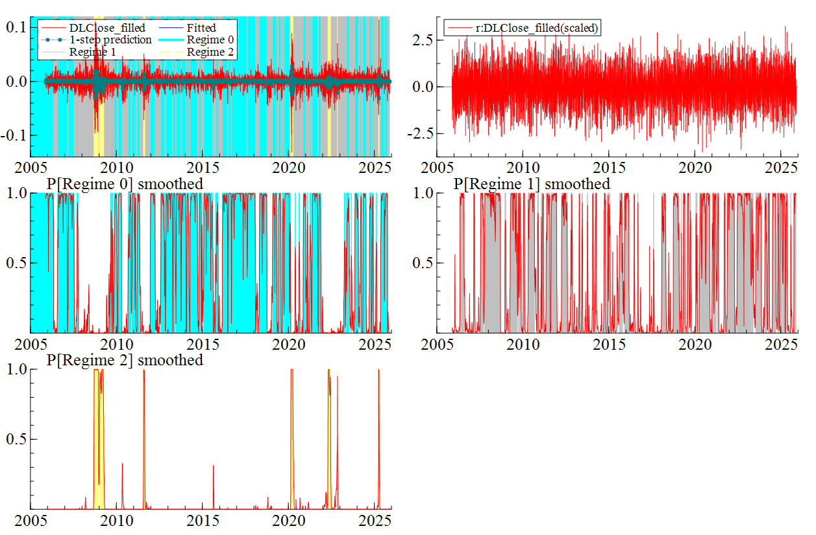

SMLL

Switching( 6) Modelling DLClose_filled by MS(3)
The dataset is: C:\Users\bteba\Documents\GitHub\MarkovSwitchingModel\database\filled\SMLL_filled.csv
The estimation sample is: 2005-11-22 - 2025-11-20

Coefficient Std.Error t-value t-prob
Constant(0) 0.00106226 0.0001814 5.86 0.000
Constant(1) -0.000528706 0.0004141 -1.28 0.202
Constant(2) -0.0137804 0.006718 -2.05 0.040
DLClose_filled_1(0) 0.0797284 0.02007 3.97 0.000
DLClose_filled_1(1) 0.0375995 0.02427 1.55 0.121
DLClose_filled_1(2) -0.124779 0.1066 -1.17 0.242

Coefficient Std.Error
sigma(0) 0.00883982 0.0001742
sigma(1) 0.0169991 0.0004288
sigma(2) 0.0583193 0.004915
p_{0|0} 0.978591 0.004632
p_{1|0} 0.0206236 0.004740
p_{0|1} 0.0338752 0.007823
p_{1|1} 0.963520 0.008001
p_{1|2} 0.0750600 0.04010
p_{2|2} 0.917389 0.03360

log-likelihood 15529.4861
no. of observations 5218 no. of parameters 15
AIC -5.94652591 SC -5.92766848
mean(DLClose_filled) 0.000269121 se(DLClose_filled) 0.0149235

Linearity LR-test Chi^2(12) = 1982.6 [0.0000]** approximate upperbound: [0.0000]**

Transition probabilities p_{i|j} = P(Regime i at t+1 | Regime j at t)
Regime 0,t Regime 1,t Regime 2,t
Regime 0,t+1 0.97859 0.033875 0.0075505
Regime 1,t+1 0.020624 0.96352 0.075060
Regime 2,t+1 0.00078513 0.0026051 0.91739

Used uniform probabilities to start recursion
Std.Error based on numerical Hessian matrix
SQPF using analytical derivatives (eps1=0.0001; eps2=0.005):
Strong convergence
Used starting values:
0.00096140 -0.0060872 0.011336 0.051219 -0.043080 -0.068555 0.0094513 0.024628 0.022918 0.95310 0.027146 0.094130 0.81358 0.25286 0.57204

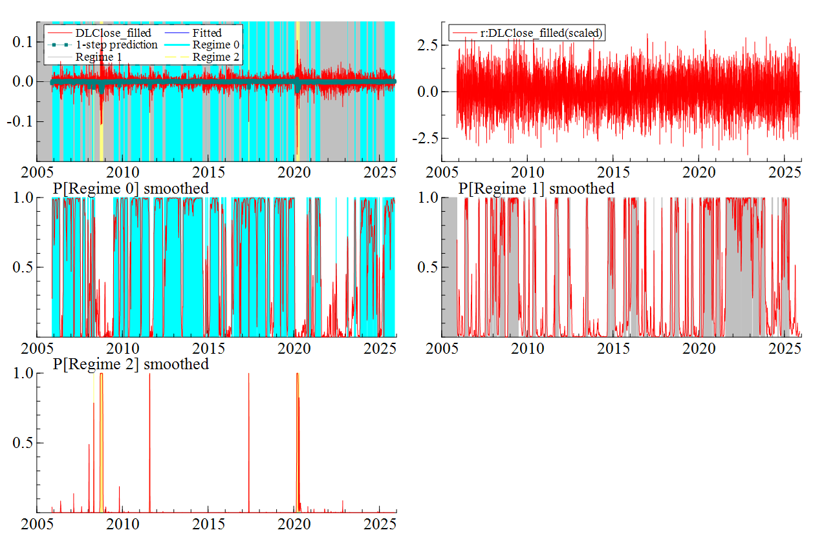

SnP500

Switching( 7) Modelling DLClose_filled by MS(3)
The dataset is: C:\Users\bteba\Documents\GitHub\MarkovSwitchingModel\database\filled\SnP500_filled.csv
The estimation sample is: 2005-11-22 - 2025-11-20

Coefficient Std.Error t-value t-prob
Constant(0) 0.00124290 0.0001131 11.0 0.000
Constant(1) -9.82847e-05 0.0002581 -0.381 0.703
Constant(2) -0.00354345 0.001809 -1.96 0.050
DLClose_filled_1(0) -0.0692434 0.02236 -3.10 0.002
DLClose_filled_1(1) -0.0298000 0.02244 -1.33 0.184
DLClose_filled_1(2) -0.212511 0.05278 -4.03 0.000

Coefficient Std.Error
sigma(0) 0.00492479 0.0001300
sigma(1) 0.0115743 0.0003552
sigma(2) 0.0309828 0.002151
p_{0|0} 0.965129 0.005499
p_{0|1} 0.0382425 0.005899
p_{1|1} 0.954865 0.006240
p_{2|2} 0.957349 0.01539

log-likelihood 17274.9712
no. of observations 5218 no. of parameters 13
AIC -6.61631705 SC -6.59997394
mean(DLClose_filled) 0.000316355 se(DLClose_filled) 0.0119855

Linearity LR-test Chi^2(10) = 3120.4 [0.0000]** approximate upperbound: [0.0000]**

Transition probabilities p_{i|j} = P(Regime i at t+1 | Regime j at t)
Regime 0,t Regime 1,t Regime 2,t
Regime 0,t+1 0.96513 0.038243 0.00000
Regime 1,t+1 0.034871 0.95486 0.042651
Regime 2,t+1 0.00000 0.0068927 0.95735

Transition probability settings (-1: free parameter, -2: 1-sum(p_{i|.})
Regime 0,t Regime 1,t Regime 2,t
Regime 0,t+1 -1.0000 -1.0000 0.00000
Regime 1,t+1 -2.0000 -1.0000 -2.0000
Regime 2,t+1 0.00000 -2.0000 -1.0000

Used uniform probabilities to start recursion
Std.Error based on numerical Hessian matrix
SQPF using analytical derivatives (eps1=0.0001; eps2=0.005):
Strong convergence
Used starting values:
0.0011064 -0.00092041 -0.0034872 -0.023615 -0.044954 -0.25662 0.0059179 0.013682 0.034288 0.95388 0.026469 0.055339 0.89895 0.23576 0.71332

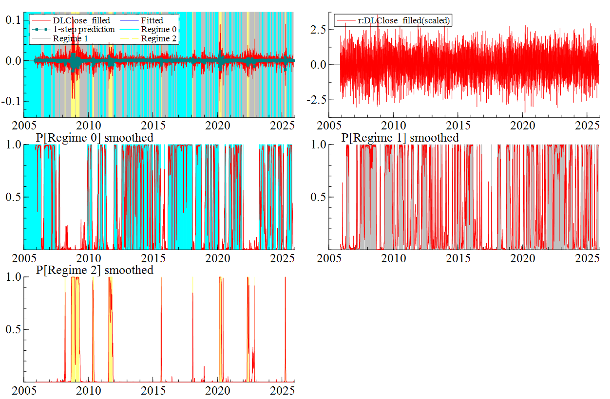

T-BOND10

Switching( 8) Modelling DLClose_filled by MS(3)
The dataset is: C:\Users\bteba\Documents\GitHub\MarkovSwitchingModel\database\filled\T-BOND10_filled.csv
The estimation sample is: 2005-11-22 - 2025-11-20

Coefficient Std.Error t-value t-prob
Constant(0) -9.49171e-05 0.0002676 -0.355 0.723
Constant(1) 0.000468261 0.0005060 0.925 0.355
Constant(2) -0.00598975 0.006970 -0.859 0.390
DLClose_filled_1(0) -0.0117895 0.02268 -0.520 0.603
DLClose_filled_1(1) -0.0269234 0.02008 -1.34 0.180
DLClose_filled_1(2) -0.0210406 0.07773 -0.271 0.787

Coefficient Std.Error
sigma(0) 0.0120168 0.0003185
sigma(1) 0.0249074 0.0005260
sigma(2) 0.0910303 0.006431
p_{0|0} 0.990262 0.003076
p_{0|1} 0.00852533 0.002605
p_{1|1} 0.980606 0.003822
p_{2|2} 0.842656 0.03801

log-likelihood 13087.2233
no. of observations 5218 no. of parameters 13
AIC -5.01120097 SC -4.99485787
mean(DLClose_filled) -1.57052e-05 se(DLClose_filled) 0.0260848

Linearity LR-test Chi^2(10) = 2925.3 [0.0000]** approximate upperbound: [0.0000]**

Transition probabilities p_{i|j} = P(Regime i at t+1 | Regime j at t)
Regime 0,t Regime 1,t Regime 2,t
Regime 0,t+1 0.99026 0.0085253 0.00000
Regime 1,t+1 0.0097384 0.98061 0.15734
Regime 2,t+1 0.00000 0.010869 0.84266

Transition probability settings (-1: free parameter, -2: 1-sum(p_{i|.})
Regime 0,t Regime 1,t Regime 2,t
Regime 0,t+1 -1.0000 -1.0000 0.00000
Regime 1,t+1 -2.0000 -1.0000 -2.0000
Regime 2,t+1 0.00000 -2.0000 -1.0000

Used uniform probabilities to start recursion
Std.Error based on numerical Hessian matrix
SQPF using analytical derivatives (eps1=0.0001; eps2=0.005):
Strong convergence
Used starting values:
-0.00012711 0.00033333 -0.0011211 -0.0064916 -0.023351 -0.026066 0.013377 0.027054 0.081132 0.95691 0.023407 0.042205 0.91759 0.29128 0.66569

